**SCIENTIFIC COMMITTEE**

**TWENTY FIRST REGULAR SESSION**

Nuku’alofa, Tonga

13-21 August 2025

**Ecosystem and climate indicators of the western and central Pacific Ocean**

**WCPFC-SC21-2025/EB-WP-01**

**14 July 2025**

Nicholas J Hill1, Simon Nicol1, Joanne Potts1, Bernadette Sloyan2, Thomas Moore2, Pearse Buchanan2, Christopher Chapman2

Contents

Executive Summary 3

Recommendations 3

Introduction 4

Proposed indicators 7

Indicator X: Centre of gravity (COG) of the purse seine fishery 7

Indicator X: Size composition of tunas 12

Discussion 16

References 18

Appendix 1: Terms of reference for adopting ecosystem and climate indicators 22

Appendix 2: Suva ecosystem and climate indicators workshop summary 24

Workshop agenda 24

Workshop participants 27

# Executive Summary

This Working Paper updates SC21 on progress regarding development of a climate and ecosystem indicators report for the western and central Pacific Ocean (WCPO).

The ecosystem and climate indicator recommendations of SC20 were:

* note the progress towards implementing the SC19 endorsed Ecosystem and Climate Indicators Workplan.
* note the delay in the first expert workshop due to travel disruptions associated with the civil disturbances through May-July in New Caledonia.

This working paper notes that a workshop was successfully held in Suva, Fiji 25-26th November 2024 that brought collaborators together from a range of organisations to inform development of a workplan and indicators.

This paper presents substantial progress of candidate indicators and production of several new indicators outlining their rationale, status and methods. There is also discussion provided detailing whether these indicators meet the established screening criteria. The outputs from this report meet the expected outcomes detailed in the current workplan. It also details a continued workplan that involves refinement of current indicators, exploration of new indicators, potential research, and planning of a second meeting in 2026.

# Recommendations

We invite SC21 to note the results of this updated climate and ecosystem indicators report and present recommendations for future work:

* Note the successful undertaking of a workshop in Suva, Fiji in November 2024 that brought collaborators together from a range of organisations to inform development of a workplan and candidate indicators.
* Note the continued development and refinement of climate and ecosystem indicators for routine updating and presentation to future SC meetings.
* Note the need for continued support of research focused on developing methods that can identify and monitor climate change-related impacts on the WCPO and its associated fisheries.
* Note the updated workplan for ecosystem and climate indicators research for 2025-26.

# Introduction

Climate change is impacting marine ecosystems and their associated fisheries (Antão et al., 2020; Hoegh-Guldberg and Bruno, 2010; Pecl et al., 2017; Poloczanska et al., 2013). This includes impacts such as shifts in the ranges of species and ecosystems (Pecl et al., 2017; Pinsky et al., 2020), changes in species physiology (Agarwal et al. 2024), and in community compositions (Johnson et al., 2011; Poloczanska et al., 2016, 2013). However, how these climate-induced impacts are manifesting themselves in individual species, ecosystems and fisheries are varied (Garciá Molinos et al., 2017).

Within the Western and Central Pacific Ocean (WCPO), there are several major oceanic currents and circulation pathways that redistribute waters from different parts of the Pacific Ocean (Ganachuad et al., 2014). These currents carry water masses with distinct ocean properties (e.g. temperature, salinity, oxygen and nutrients). Changes in their intensity, composition or position can have an outsized impact on the oceanographic composition of the WCPO. Such changes to the oceanography of the WCPO are typically driven by large-scale climate, including both anthropogenic trends and natural variability modes, such as the El Niño Southern Oscillation (ENSO) and Pacific Decadal Oscillation (IPO). This variability in ocean circulation is not uniform and thus impacts on marine ecosystems are not consistent throughout the WCPO. Therefore, it is essential to understand how climate change and natural variability, and their interactions might shift the oceanographic structure and composition of the WCPO.

The WCPO supports the world’s largest and most valuable tuna fishery in the world (FAO, 2024). A prominent oceanographic feature in this region is the western pacific warm pool which is characterised as a large body of water above 28oC that sits in the equatorial WCPO and is the main fishing grounds for the Western and Central Pacific Fisheries Commission (WCPFC) purse seine fishery. The warm pool shifts in size with natural climate variability, namely with ENSO events (Leung et al., 2022; Weller et al., 2016). Tuna and the WCPFC purse seine fishery shift with the warm pool following favourable environmental conditions with several tropical tuna species also known to spawn in this region (Lehodey et al., 2020, 2003; Ohashi et al., 2019). With the effects of climate change, predictions suggest an eastward expansion of the western pacific warm pool and with it, an eastward shift in tuna biomass (Bell et al., 2021; Weller et al., 2016). If tuna biomass does shift, this could have flow on effects to Pacific Island countries and territories (PICTs) which are highly dependent on fisheries for food security and as a source of income (Bell et al., 2015; Gillett and Fong, 2023).

In response to climate change, fisheries administrations are increasingly looking at ways to monitor and adapt to its effects (Taylor and Walter, 2024). Within tuna regional fisheries management organisations (RFMOs), climate and ecosystem indicator reports are now being regularly produced to monitor environmental conditions and to track if any underlying shifts in ecosystems, fisheries or species of interest are occurring (Griffiths and Fuller, 2019; Juan-Jordá et al., 2018; SPC, 2023). Since 2015, the WCPFC has produced a series of reports that have explored the development of climate and ecosystem indicators for the WCPO (Anon, 2015), and a set of candidate indicators have been reported since 2019 at SC15 (Allain et al., 2021, 2020; Juan-Jordá et al., 2019; SPC, 2024, 2023, 2022). Candidate indicators produced thus far have generally been empirical in nature, such as summarising catch and effort location, key environmental variables (e.g. sea surface temperature, ENSO events), and tuna biology (e.g. mean length of catch). However, the empirical nature of many of these indicators can make it difficult to disentangle natural climate variability, changes in fishing behaviour, and any underlying trends.

As part of this ongoing work of developing ecosystem and climate indicators, a workshop was recently held in Suva, Fiji November 2024 to devise a workplan and discuss candidate indicators. Details of this workshop are provided in Appendix 2. In summary, this workshop brought together approximately 25 participants both in person and online from a range of organisations including SPC, NOAA, WCPFC, CSIRO, private sector, NGOs and member country representatives. The workshop discussed the development of a series of indicators that accurately detail the current climate for the Pacific region and its fisheries so that it can better monitor and adapt to the effects of climate change and ocean variability.

### Objectives

The intent of developing an ecosystem and climate indicators report is to present a summary of the current environment and climate of the WCPO which will provide the SC with the capability to report on ecosystem and climate change impacts in its annual reporting to WCPFC. Ultimately, it is the hope that this report will be adopted by the Commission and routinely produced to provide up-to-date information to the SC and WCPFC to help inform decision-making and support its application of an ecosystem-based approach to fisheries management (EAFM). This iteration of the report represents a continuation of this work.

Here, six candidate indicators are presented for consideration to be included in this report going forward. These include ocean indicators such as sea surface temperature variability and area of the western pacific warm pool as well as several fisheries indicators. Indicators are introduced and provisionally assessed against the SC12 screening criteria detailed in Appendix 1 which required a combination of the indicator being reflective of the current environment, responsive to changes, cost effective, and science-based among others. The candidate indicators presented include:

1. Sea surface Temperature variability, regionally and for EEZ.
2. Depth subsurface ocean isotherms and variability from the annual mean state
3. Area and volume of the western pacific warm pool and variability from the mean state
4. Depth and thickness of Oxygen depleted waters where oxygen depleted waters may be defined as 1.5 - 3 mL/Litre (45-90 umol kg-1)
5. Centre of gravity (COG) of the purse seine fishery
6. Size composition of tunas

Below, a rationale for the inclusion of each indicator is given along with a summary of their status and trends over time and whether they meet the SC12 criteria (Appendix 1). As part of this report, the sensitivity and robustness of some of these candidate indicators will be further evaluated.

# Proposed indicators

## Indicator X: Centre of gravity (COG) of the purse seine fishery

Rationale: The WCPFC purse seine fishery predominately operates in the western pacific warm pool. The warm pool is a large, warm body of water at or above 28oC that sits in the equatorial WCPO. The warm pool naturally varies in size and extent, and in particular with ENSO events, which influences where effort and catch consequently occurs in the purse seine fishery (Senina et al., 2008). The warm pool is also considered as an important spawning ground for tuna species, in particular skipjack tuna and so changes in its size, structure or position may also influence the productivity of tuna (Ashida, 2020; Fujioka et al., 2024).

With the impacts of climate change, the warm pool is predicted to increase in size, driving a potential eastward shift in tuna biomass (Bell et al., 2021; Lehodey et al., 2013). By monitoring the centre of gravity (COG) of purse seine effort and catch, we can potentially monitor if fisheries are responding to these predicted changes and by proxy tuna dynamics. Any shift in the location of the purse seine fishery is also relevant as it relates to income for PICTs when fishing occurs within their EEZ.

Status: For effort, there is a clear distinction in trends over time by set type in COG (Figure 1). For unassociated sets, effort COG shows interannual variability but no clear underlying trend from 1990-2023. In contrast, there is an eastward shift in the COG of drifting FAD-associated sets over time. It appears that the increased uptake of FAD-associated fishing has contributed to trends in the eastward shift in purse seine effort over time. It is difficult to determine if this is a climate related shift in the warm pool and tuna dynamics, or if it is a shift in fishing behaviour with different trends across set type, as well as ENSO events.

For catch, there are similar trends in COG, with variable trends across species (Figure 2). Bigeye tuna (BET, *Thunnus obesus*) shows an eastward shift over time, whereas for skipjack tuna (SKJ, *Katsuwonus pelamis*) and yellowfin tuna (YFT, *Thunnus albacares*) it is difficult to determine if a shift is occurring or if it is underlying natural variability. As with effort, it is difficult to disentangle shifts in tuna catch and changes in fishing behaviour to explain these underlying trends.

To disentangle the effects of these variables (e.g. set type, ENSO) on purse seine COG over time, the longitudinal distribution of purse seine effort was modelled accounting for a number of these variables. The results of this analysis are summarised in Figure 3 comparing outputs from the analysis with COG indices of effort (for longitude only). In summary, generalized additive models (GAMs) were applied to purse seine effort data in R using the package ‘*mgcv*’, modelling longitude as function of several variables known to influence effort including month, set type, flag and ENSO event (R Core Team, 2024; Wood, 2011). Outputs from this model showed a variable trend in longitude over time with no clear signal, and with vessel flag having a large effect. It was also apparent from this analysis that different flagged vessels behave differently within the fishery, with some flexibly fishing throughout the convention area while others consistently fish similar regions each year. This suggests that if climate change does affect the distribution of tuna, some vessels and flags will be more susceptible to these changes than others. However, currently it appears that COG cannot reliably detect a climate signal given the magnitude of inherent variability in the data and fishery due to other variables such as set type and flag. Therefore, this indicator may not meet criteria four from the SC12 criteria which requires the indicator to be responsive and with minimal time lags (Appendix 1).

Description: Best estimates of total purse seine catches of BET, YFT and SKJ were used to determine the COG of catch, and best estimates of effort by set type for the COG of effort. Data used were extracted from SBEST databases using raised (aggregated) 1x1 degree purse seine fishery data where set type information was available. Catches and effort were constrained to WCPFC regions 6-8 (latitude: -20oS – 10oN, longitude: 140oE – 210oE) and from years 1990-2023 (Vidal et al., 2020). Catches and effort from domestic Indonesian, Vietnamese, and Philippines flagged vessels were not considered given differences in vessel class and fishing strategy. Associated purse seine sets were considered as sets made on drifting FADs only, floating objects and anchored FADs were not considered in this analysis. The COG is an annual estimate of the weighted mean position of catch and effort where the number of sets is used to weight the effort COG, and catch to weight the catch COG by species.

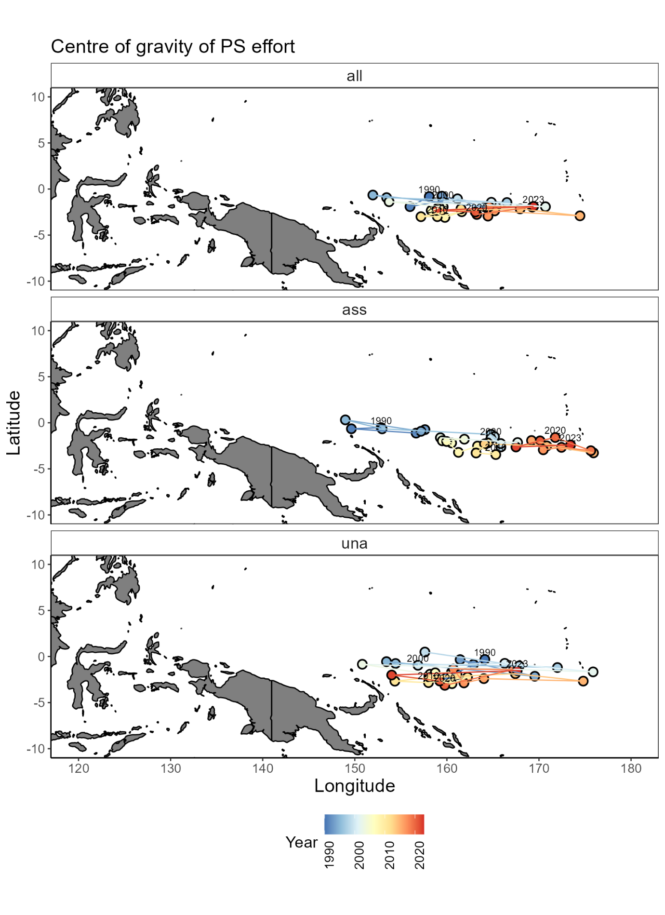

Figure 1: Centre of gravity of WCPFC purse seine effort by set type: all sets (all), drifting FAD-associated sets (ass), and free-school unassociated sets (una) from 1990-2023.

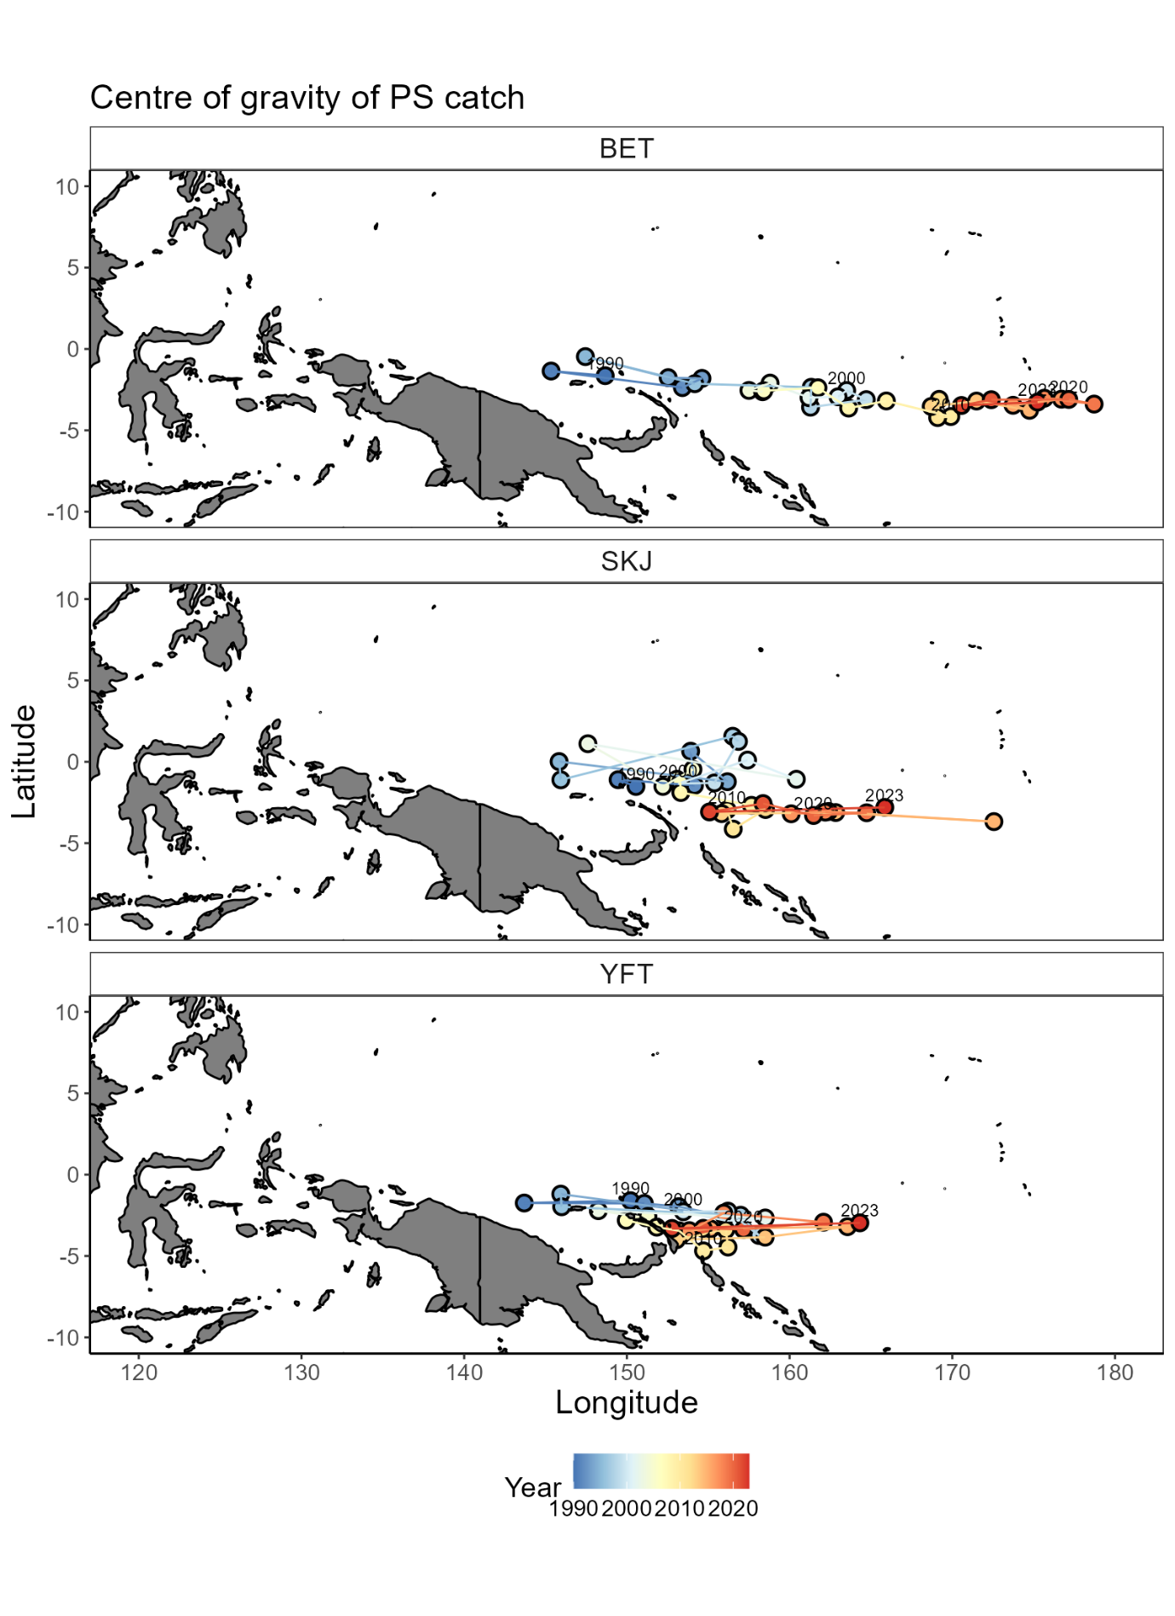

Figure 2: Centre of gravity of WCPFC purse seine catch of bigeye tuna (BET), skipjack tuna (SKJ), and yellowfin tuna (YFT) from all sets from 1990-2023.

Figure 3: Comparison of indices used to monitor the longitudinal distribution of the WCPFC purse seine fishery from 1990-2023. Black = modelled longitude. Red = unstandardised mean longitude of effort. Blue = COG of catch. Green = COG of effort. Dashed black = mean longitude from 1995-2005.

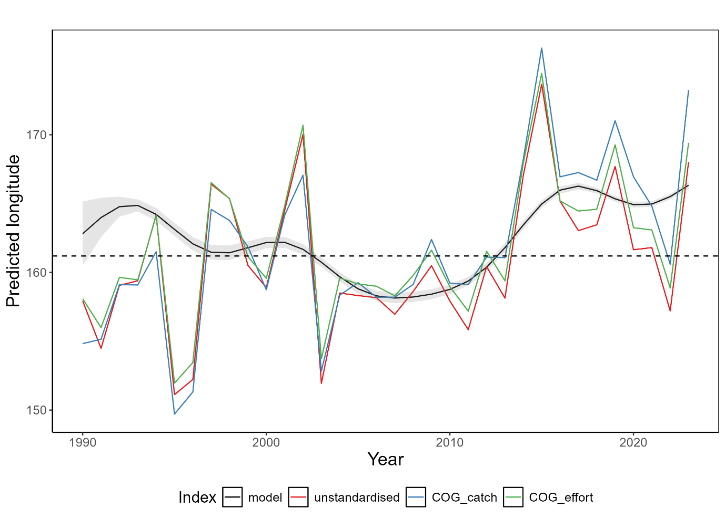

## Indicator X: Size composition of tunas

Rationale:The size composition of a fish population is influenced by a range of factors including fishing and its environment. For example, changing oceanographic conditions could influence prey availability or recruitment having knock-on effects on fish size composition. How the environment and climate change is influencing tuna size composition is not well known. However, by monitoring tuna size composition, any changes can be identified which can help determine sustainability of the fishery and inform management decisions.

Status:Trends in the size composition of tunas has varied from 1990-2023 and there are no clear trends (Figure 4; Figure 5). This is likely a reflection of several factors including changes in sampling design, fishing strategy, and the underlying environment and populations.

For bigeye tuna (BET), their size composition has fluctuated over time rising to values above the 1990-2000 historical mean of 122cm from 2007-2012 before declining to approximately 2018. In recent years, length composition has increased and the mean length in 2023 of 125cm is above the historical mean. Throughout this time, most BET catches in the longline fishery have been above the length at 50% maturity of 103cm (Farley et al., 2017). There has been a minor upward trend in the proportion of small fish caught (<105cm), and a decrease in the proportion of large fish caught (>140cm) throughout the timeseries (Figure 5). However, this trend is not clear, and recent years have shown a shift in the opposing direction.

For SKJ, their size composition has been more variable which is likely a reflection of fishing and sampling programs. In recent years, SKJ size composition has declined with nearly 75% of the length composition below the historical mean length of 51.3cm in 2022. Unlike YFT and BET, catches have predominately been below the length at 50% maturity of 55cm which is likely due to most catch and sampling coming from the purse seine fishery (Ohashi et al., 2019).

For YFT, a decline in their size composition since 2012 is apparent. From 2000-2010, they show a similar trend to BET where their size composition declined in the early 2000s before rising around 2010. However, in contrast to BET their size composition has since declined and consistently remained below the historical mean value of 120.8cm since 2012, with a 2023 mean length of 113.9cm. Like BET, most of the size composition remains above the length at 50% maturity of 105cm. In terms of length proportions, there has been a slight increase in the proportion of small fish caught, and a slight decrease in the number of large fish caught.

There is no evidence of an underlying climate trend in the length composition of tunas over time. Given the empirical nature of this indicator, it remains difficult to disentangle a range of variables that are likely to influence the size composition of tunas such as the resolution and robustness of input data, changes in fishing pressure and strategy, natural environmental variability and so on. Further, empirical length indicators are generally not considered responsive to population level shifts in abundance and thus are not likely to be an appropriate indicator. It is unlikely that this indicator can reliably detect a climate signal and therefore, may not meet criteria four from the SC12 criteria which requires the indicator to be responsive and with minimal time lags (Appendix 1).

Description:Length composition data for the three tuna species were extracted from observer and port sampling programs from SPC databases for the years 1990-2023. Longline data were used for BET and YFT, and a combination of longline and purse seine data for SKJ. Where required, total (or other) lengths were converted to fork length measurements using well established conversion factors (Macdonald et al., 2023, 2022). Any outliers in the data were removed and length composition metrics extracted. This included estimating a three-year rolling mean of: 1) small fish: the percentage of fish that were below the 20th percentile of fish sampled from 1990-2000, 2) mean fish: the percentage of fish above the mean length of fish sampled from 1990-2000, and 3) big fish: the percentage of fish above the 80th percentile of fish sampled from 1990-2000. By monitoring these three indicators rather than just the mean length, an improved understanding of a species size composition is gained.

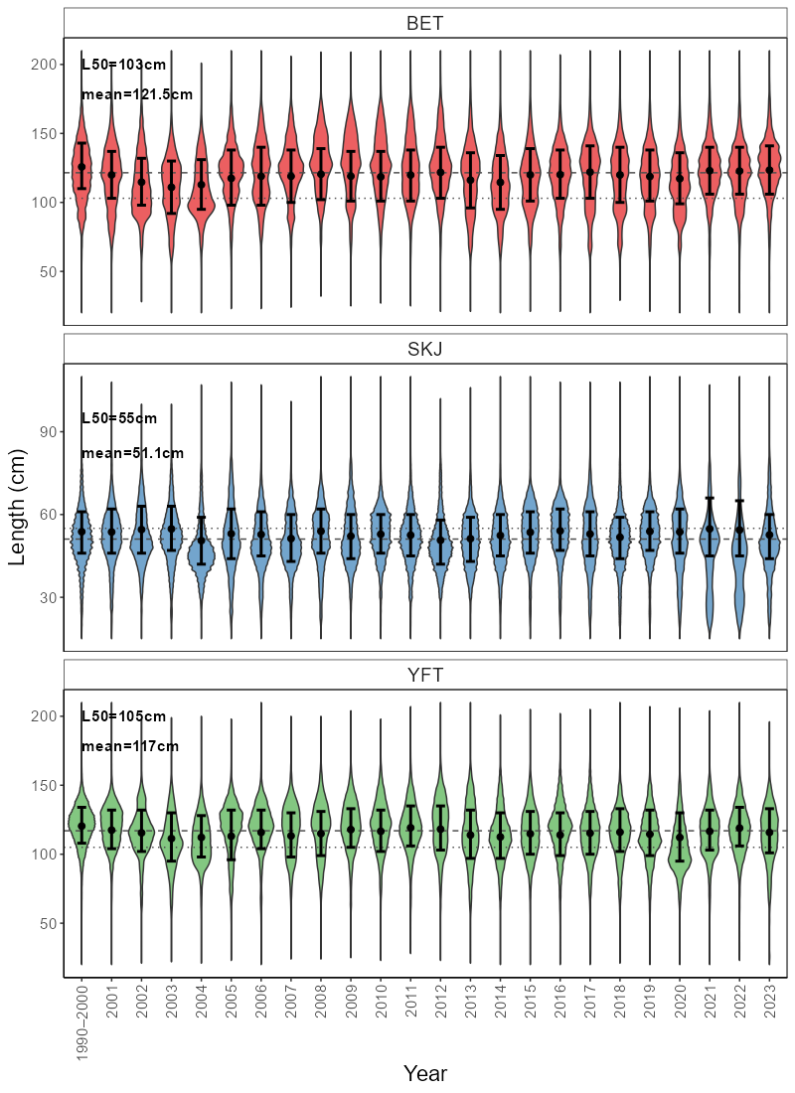

Figure 4: Length composition (cm) of bigeye tuna (BET), skipjack tuna (SKJ), and yellowfin tuna (YFT) in WCPFC longline fisheries (plus purse seine for SKJ) from 1990-2023. Dashed line = mean length from 1990-2000, dotted line = length at 50% maturity. Black dot = mean length with 25th-75th percentile error bars.

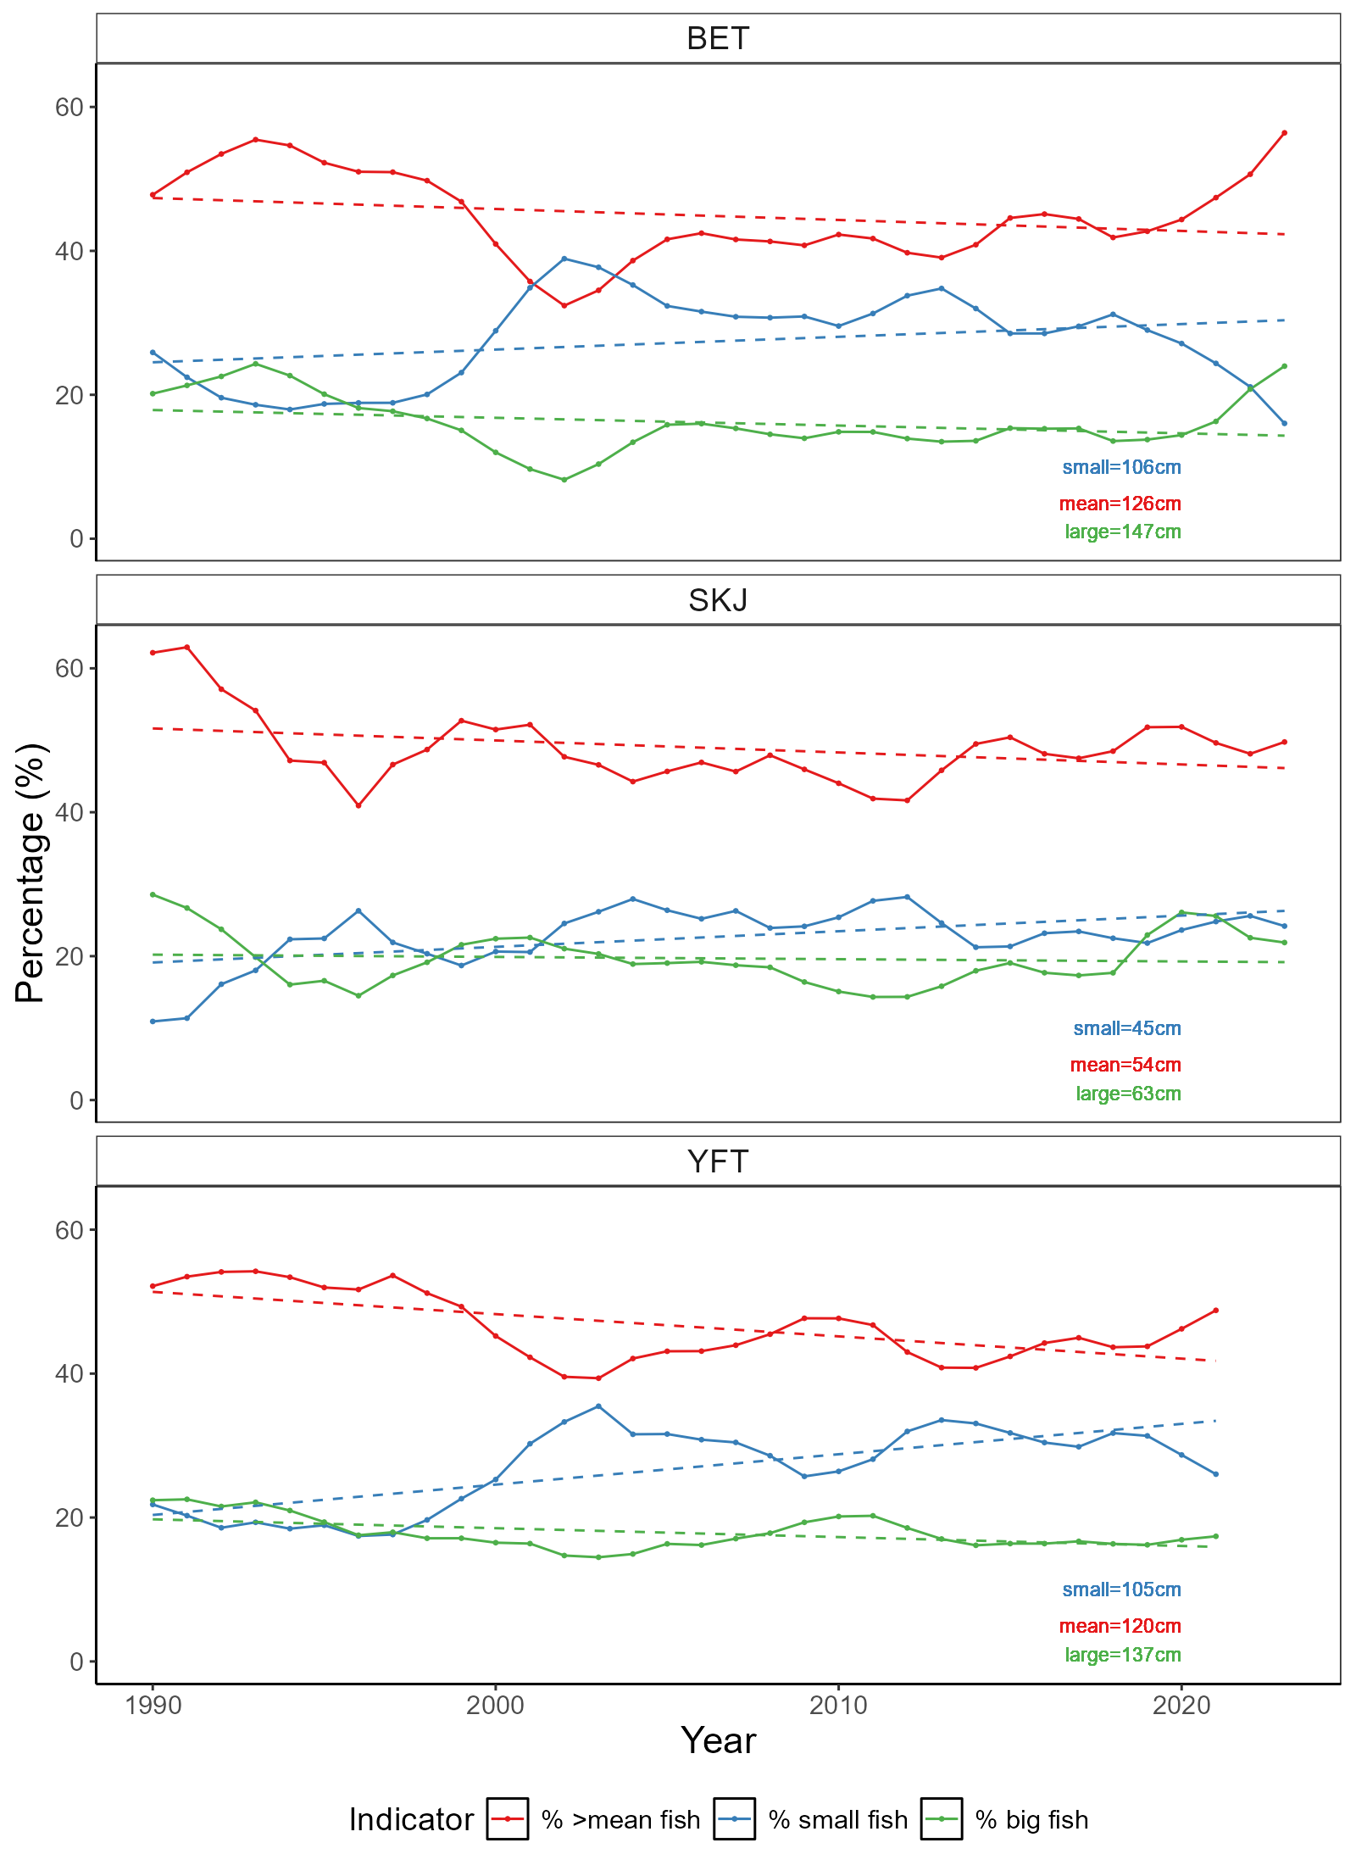

Figure 5: Length indicators for bigeye tuna (BET), skipjack tuna (SKJ), and yellowfin tuna (YFT) in WCPFC longline fisheries (plus purse seine for SKJ) from 1990-2023. Blue = % of fish below the 20th percentile measured from 1990-2000. Red = % of fish above the mean length measured from 1990-2000. Green = % of fish above the 80th percentile of fish measured from 1990-2000. Dashed lines represent linear models fit to each line to get a general trend line.

# Discussion

This report presents the continued development and exploration of ecosystem and climate indicators for the WCPFC. The process of developing and selecting indicators is ongoing and is likely to evolve over time. In this report, six candidate indicators have been presented to complement those first three proposed in the SC19 report (Table 1). Several new ocean climate indicators were produced that provide a more complete outlook of the major oceanographic features of the WCPO to be monitored over time. These indicators will require continued development and refinement, but their identification represents an important step forward. Two fishery indicators explored in previous SC reports were also updated and further examined herein. Although providing information and trends on WCPFC fisheries over time, underlying and inherent variability in these indicators likely renders them unresponsive as a climate indicator.

For the ocean climate indicators,…

For the fishery indicators explored here, it is not clear that either would be able to identify an underlying climate signal and therefore may not meet criteria four in relation to being responsive to climate and fishing pressure-related changes (Table 1). This is due to the fishery dependent nature of these indicators and their input data, making it difficult to disentangle a range of other variables (e.g. fishing strategy, data collection programs, flag) that influence these indicators. These fishery indicators do meet several of the other criteria and characterise trends in the WCPFC fishery well, and so may be more appropriate in other reports such as the Tuna Fisheries Assessment Report (Hare et al., 2024). For indicators derived from fisheries data to meet these criteria in the future may require indicators to be modelled to remove the effect of some of these variables, or alternate data sources explored. Preliminary modelling was used to explore both the COG and length composition indicators in this report, and confirmed that these indicators are being influenced heavily by other underlying variables.

Table 1: Performance of proposed indicators relative to SC12 screening criteria which can be found in Appendix 1 of this report. *Proposed indicators presented from SC19.

|  |  |  |  |  |  |  |  |  |  |
| --- | --- | --- | --- | --- | --- | --- | --- | --- | --- |
| **Indicator** | **SC12 Criteria** | | | | | | | | |
| **1** | **2** | **3** | **4** | **5** | **6** | **7** | **8** | **9** |
| *ENSO variability\** | ✓ | ✓ | ✓ | ✓ | ✓ | ✓ | X | ✓ | ✓ |
| *Ocean productivity\** | ✓ | ✓ | ✓ | ✓ | ✓ | ✓ | X | ✓ | ✓ |
| *Warm pool area/volume\** | ✓ | ✓ | ✓ | ✓ | ✓ | ✓ | X | ✓ | ✓ |
| Sea surface temperature variability | *✓* | *✓* | *✓* | *✓* | *✓* | *✓* | *✓* | *✓* | *✓* |
| Depth of isotherm | ✓ | ✓ | ✓ | ✓ | ✓ | ✓ | ✓ | ✓ | ✓ |
| Area/Volume of western pacific warm pool | ✓ | ✓ | ✓ | ✓ | ✓ | ✓ | ✓ | ✓ | ✓ |
| Depth of oxycline | ✓ | ✓ | ✓ | ✓ | ✓ | ✓ | ✓ | ✓ | ✓ |
| Centre of gravity of purse seine fishery | ✓ | ✓ | ✓ | X | ✓ | ✓ | ✓ | ✓ | ✓ |
| Size composition of tunas | ✓ | ✓ | ✓ | X | ✓ | ✓ | ✓ | ✓ | ✓ |

At SC19 (SPC, 2023), three candidate indicators were proposed including ENSO variability, ocean productivity, and warm pool area. These were found to meet all criteria except for criteria seven which relates to the ability of the indicator to be scalable to national and sub-regional scales. Ocean productivity was not updated herein, but could be further explored in the future. The warm pool area indicator was updated and has been explored in a way that can be communicated at national scales potentially overcoming this issue.

Work plan paragraph…

We invite SC21 to note the progress made on the exploration, development and testing of candidate ecosystem and climate indicators for the WCPO. Since SC20:

* A successful workshop was held in Suva, Fiji in November 2024.
* Several new candidate indicators have been developed, and several proposed fishery indicators have been further explored and tested against the screening criteria.
* The workplan detailed in previous SC reports is being upheld and updated.
* Activities for 2025-26 workplan include:
  + Continued refinement of the ocean climate indicators proposed here.
  + Continued exploration of modelled fishery indicators.
  + Continued development of methods to remove biases in earth system models and detrending of climate change to commence analyses that can attribute impacts to greenhouse gas emissions.
  + Organisation of a workshop to be held in 2026.
  + RFMO cooperation/collaboration…

# References

Allain, V., Hare, S., Macdonald, J., Machful, P., Nicol, S., Phillips, J.S., Portal, A., Vidal, T., Williams, P., 2021. WCPO Ecosystem and Climate Indicators from 2000 to 2020. WCPFC Scientific Committee 17th Regular Session, WCPFC-SC17-2021/EB-IP-09, Online.

Allain, V., Macdonald, J., Nicol, S., Phillips, J.S., Vourey, E., 2020. Ecosystem and climate indicators for consideration within the WCPO. WCPFC Scientific Committee 16th Regular Session, WCPFC-SC16-2020/EB-IP-07, Online.

Anon, 2015. Summary Report: Commission for the Conservation and Management of Highly Migratory Fish Stocks in the Western and Central Pacific Ocean. WCPFC Scientific Committee 11th Regular Session, Pohnpei.

Antão, L.H., Bates, A.E., Blowes, S.A., Waldock, C., Supp, S.R., Magurran, A.E., Dornelas, M., Schipper, A.M., 2020. Temperature-related biodiversity change across temperate marine and terrestrial systems. Nat Ecol Evol. <https://doi.org/10.1101/841833>

Ashida, H., 2020. Spatial and temporal differences in the reproductive traits of skipjack tuna Katsuwonus pelamis between the subtropical and temperate western Pacific Ocean. Fish Res 221, 105352. <https://doi.org/10.1016/j.fishres.2019.105352>

Bell, J.D., Allain, V., Allison, E.H., Andréfouët, S., Andrew, N.L., Batty, M.J., Blanc, M., Dambacher, J.M., Hampton, J., Hanich, Q., Harley, S., Lorrain, A., McCoy, M., McTurk, N., Nicol, S., Pilling, G., Point, D., Sharp, M.K., Vivili, P., Williams, P., 2015. Diversifying the use of tuna to improve food security and public health in Pacific Island countries and territories. Mar Policy 51, 584–591. <https://doi.org/10.1016/j.marpol.2014.10.005>

Bell, J.D., Senina, I., Adams, T., Aumont, O., Calmettes, B., Clark, S., Dessert, M., Gehlen, M., Gorgues, T., Hampton, J., Hanich, Q., Harden-Davies, H., Hare, S.R., Holmes, G., Lehodey, P., Lengaigne, M., Mansfield, W., Menkes, C., Nicol, S., Ota, Y., Pasisi, C., Pilling, G., Reid, C., Ronneberg, E., Gupta, A. Sen, Seto, K.L., Smith, N., Taei, S., Tsamenyi, M., Williams, P., 2021. Pathways to sustaining tuna-dependent Pacific Island economies during climate change. Nat Sustain 4, 900–910. <https://doi.org/10.1038/s41893-021-00745-z>

FAO, 2024. The State of World Fisheries and Aquaculture 2024 - Blue Transformation in action, The State of World Fisheries and Aquaculture 2024. FAO, Rome. <https://doi.org/10.4060/cd0683en>

Farley, J., Eveson, P., Krusic-Golub, K., Sanchez, C., Roupsard, F., Mckechnie, S., Nicol, S., Leroy, B., Smith, N., Chang, S.-K., 2017. Project 35: Age, growth and maturity of bigeye tuna in the western and central Pacific Ocean. WCPFC Scientific Committee 13th Regular Session, WCPFC-SC13-2017/ SA-WP-01, Rarotonga.

Fujioka, K., Aoki, Y., Tsuda, Y., Okamoto, K., Tsuchida, H., Sasaki, A., Kiyofuji, H., 2024. Influence of temperature on hatching success of skipjack tuna (Katsuwonus pelamis): Implications for spawning availability of warm habitats. J Fish Biol 105, 372–377. <https://doi.org/10.1111/jfb.15767>

Garciá Molinos, J., Burrows, M.T., Poloczanska, E.S., 2017. Ocean currents modify the coupling between climate change and biogeographical shifts. Sci Rep 7. <https://doi.org/10.1038/s41598-017-01309-y>

Ganachuad, A., et al., 2014. The Southwest Pacific Ocean Circulation and Climate Experiment (SPICE), Journal of Geophysical Research, 119, doi:10.1002/2013JC009678

Gillett, R., Fong, M., 2023. Fisheries in the Economies of Pacific Island Countries and Territories (Benefish Study 4). Pacific Community, Noumea.

Griffiths, S., Fuller, L., 2019. Ecosystem Considerations. Inter-American Tropical Tuna Commission, Scientific Advisory Committee Tenth Meeting, San Diego.

Hare, S., Pilling, G., Scott, R., Vidal, T., Williams, P., 2024. A Compendium of Fisheries Indicators for Target Tuna Stocks in the WCPFC Convention Area. WCPFC Scientific Committee 20th Regular Session, WCPFC-SC20-2024/SA-WP-07 Rev. 1, Manila.

Hoegh-Guldberg, O., Bruno, J.F., 2010. The impact of climate change on the world’s marine ecosystems. Science (1979). <https://doi.org/10.1126/science.1189930>

Johnson, C.R., Banks, S.C., Barrett, N.S., Cazassus, F., Dunstan, P.K., Edgar, G.J., Frusher, S.D., Gardner, C., Haddon, M., Helidoniotis, F., Hill, K.L., Holbrook, N.J., Hosie, G.W., Last, P.R., Ling, S.D., Melbourne-Thomas, J., Miller, K., Pecl, G.T., Richardson, A.J., Ridgway, K.R., Rintoul, S.R., Ritz, D.A., Ross, D.J., Sanderson, J.C., Shepherd, S.A., Slotwinski, A., Swadling, K.M., Taw, N., 2011. Climate change cascades: Shifts in oceanography, species’ ranges and subtidal marine community dynamics in eastern Tasmania. J Exp Mar Biol Ecol. <https://doi.org/10.1016/j.jembe.2011.02.032>

Juan-Jordá, M., Murua, H., Apostolaki, P., Lynam, C., Rodriguez, A., Barrionuevo, J., Abascal, F., Coelho, R., Todorovic, S., Billet, N., Uyarra, M., Andonegi, E., Lopez, J., 2019. Selecting ecosystem indicators for fisheries targeting highly migratory species: An EU project to advance the operationalization of the EAFM in ICCAT and IOTC. WCPFC Scientific Committee 15th Regular Session, WCPFC-SC15-2019/EB-WP-12, Pohnpei.

Juan-Jordá, M.J., Murua, H., Arrizabalaga, H., Hanke, A., 2018. A template for an indicator-based ecosystem report card for ICCAT. International Commission for the Conservation of Atlantic Tunas, SCRS/2017/140, Sci. Pap. ICCAT.

Lehodey, P., Bertrand, A., Hobday, A.J., Kiyofuji, H., McClatchie, S., Menkès, C.E., Pilling, G., Polovina, J., Tommasi, D., 2020. ENSO Impact on Marine Fisheries and Ecosystems, in: Geophysical Monograph Series. John Wiley and Sons Inc, pp. 429–451. <https://doi.org/10.1002/9781119548164.ch19>

Lehodey, P., Chai, F., Hampton, J., 2003. Modelling climate-related variability of tuna populations from a coupled ocean-biogeochemical-populations dynamics model. Fish Oceanogr 12, 483–494.

Lehodey, P., Senina, I., Calmettes, B., Hampton, J., Nicol, S., 2013. Modelling the impact of climate change on Pacific skipjack tuna population and fisheries. Clim Change 119, 95–109. <https://doi.org/10.1007/s10584-012-0595-1>

Leung, J.C.H., Zhang, B., Gan, Q., Wang, L., Qian, W., Hu, Z.Z., 2022. Differential expansion speeds of Indo-Pacific warm pool and deep convection favoring pool under greenhouse warming. NPJ Clim Atmos Sci 5. <https://doi.org/10.1038/s41612-022-00315-w>

Macdonald, J., Williams, P., Roupsard, F., Sanchez, C., Bell, L., Chang, S.-K., Contreras, R., Ghergariu, M., Hosken, M., Hoyle, S., Cuu, S.N., Park, T., Potts, J., Schneiter, E., Nicol, S., 2023. Project 90 update: Better data on fish weights and lengths for scientific analyses. WCPFC Scientific Committee 19th Regular Session, WCPFC-SC19-2023/ST-IP-04, Koror.

Macdonald, J., Williams, P., Sanchez, C., Schneiter, E., Prasad, S., Ghergariu, M., Hosken, M., Panizza, A., Park, T., Guillou, A., Nicol, S., 2022. Project 90 update: Better data on fish weights and lengths for scientific analyses. WCPFC Scientific Committee 18th Regular Session, WCPFC-SC18-2022/ST-IP-04, Online.

Magnusson, A., Day, J., Teears, T., Hampton, J., Davies, N., Castillo Jordán, C., Peatman, T., Scott, R., Scutt Phillips, J., Mckechnie, S., Scott, F., Yao, N., Natadra, R., Pilling, G., Williams, P., Hamer, P., 2023. Stock assessment of yellowfin tuna in the western and central Pacific Ocean: 2023. WCPFC Scientific Committee 19th Regular Session, WCPFC-SC19-2023/SA-WP-04, Koror.

Ohashi, S., Aoki, Y., Tanaka, F., Fujioka, K., Aoki, A., Kiyofuji, H., 2019. Reproductive traits of female skipjack tuna Katsuwonus pelamis in the western and central Pacific Ocean (WCPO). Scientific Committee 15th Regular Session, WCPFC-SC15-2019/SA-WP-10, Pohnpei.

Pecl, G.T., Araújo, M.B., Bell, J.D., Blanchard, J., Bonebrake, T.C., Chen, I.-C., Clark, T.D., Colwell, R.K., Danielsen, F., Evengård, B., Falconi, L., Ferrier, S., Frusher, S., Garcia, R.A., Griffis, R.B., Hobday, A.J., Janion-Scheepers, C., Jarzyna, M.A., Jennings, S., Lenoir, J., Linnetved, H.I., Martin, V.Y., McCormack, P.C., McDonald, J., Mitchell, N.J., Mustonen, T., Pandolfi, J.M., Pettorelli, N., Popova, E., Robinson, S.A., Scheffers, B.R., Shaw, J.D., Sorte, C.J.B., Strugnell, J.M., Sunday, J.M., Tuanmu, M.N., Vergés, A., Villanueva, C., Wernberg, T., Wapstra, E., Williams, S.E., 2017. Biodiversity redistribution under climate change: Impacts on ecosystems and human well-being. Science (1979). <https://doi.org/10.1126/science.aai9214>

Pinsky, M.L., Selden, R.L., Kitchel, Z.J., 2020. Climate-Driven Shifts in Marine Species Ranges: Scaling from Organisms to Communities. Ann Rev Mar Sci 12, 153–179. <https://doi.org/10.1146/annurev-marine-010419>

Poloczanska, E.S., Brown, C.J., Sydeman, W.J., Kiessling, W., Schoeman, D.S., Moore, P.J., Brander, K., Bruno, J.F., Buckley, L.B., Burrows, M.T., Duarte, C.M., Halpern, B.S., Holding, J., Kappel, C. V., O’Connor, M.I., Pandolfi, J.M., Parmesan, C., Schwing, F., Thompson, S.A., Richardson, A.J., 2013. Global imprint of climate change on marine life. Nat Clim Chang 3, 919–925. <https://doi.org/10.1038/nclimate1958>

Poloczanska, E.S., Burrows, M.T., Brown, C.J., Molinos, J.G., Halpern, B.S., Hoegh-Guldberg, O., Kappel, C. V., Moore, P.J., Richardson, A.J., Schoeman, D.S., Sydeman, W.J., 2016. Responses of marine organisms to climate change across oceans. Front Mar Sci. <https://doi.org/10.3389/fmars.2016.00062>

R Core Team, 2024. R: A language and environment for statistical computing.

Senina, I., Sibert, J., Lehodey, P., 2008. Parameter estimation for basin-scale ecosystem-linked population models of large pelagic predators: Application to skipjack tuna. Prog Oceanogr 78, 319–335. <https://doi.org/10.1016/j.pocean.2008.06.003>

SPC, 2024. Ecosystem and climate indicators. Oceanic Fisheries Programme, Pacific Community, WCPFC Scientific Committee 20th Regular Session, WCPFC-SC20-2024/EB-WP-01, Manila.

SPC, 2023. Ecosystem and Climate Indicators. Oceanic Fisheries Programme, Pacific Community, WCPFC Scientific Committee Nineteenth Regular Session, WCPFC-SC19-2023/EB-WP-01, Koror.

SPC, 2022. Ecosystem and climate indicators. Oceanic Fisheries Programme, Pacific Community, WCPFC Scientific Committee 18th Regular Session, WCPFC-SC18-2022/EB-WP-01, Online.

Taylor, N.G., Walter, J.F., 2024. Incorporating climate considerations into fisheries assessments and management advice at ICCAT, International Commission for the Conservation of Atlantic Tunas, SCRS/2024/081, Collect. Vol. Sci. Pap. ICCAT.

Vidal, T., Hamer, P., Escalle, L., Pilling, G., 2020. Assessing trends in skipjack tuna abundance from purse seine catch and effort data in the WCPO. Oceanic Fisheries Programme, Pacific Community, WCPFC Scientific Committee Sixteenth Regular Session, WCPFC-SC16-2020/SA-IP-09, Online.

Weller, E., Min, S.K., Cai, W., Zwiers, F.W., Kim, Y.H., Lee, D., 2016. Human-caused Indo-Pacific warm pool expansion. Sci Adv 2, e1501719. <https://doi.org/10.1126/sciadv.1501719>

Wood, S.N., 2011. Fast stable restricted maximum likelihood and marginal likelihood estimation of semiparametric generalized linear models. J R Stat Soc Series B Stat Methodol 73, 3–36. https://doi.org/10.1111/j.1467-9868.2010.00749.

# Appendix 1: Terms of reference for adopting ecosystem and climate indicators

The text below was extracted from (SPC, 2023).

### Terms of Reference

*A drafted terms of reference for the Ecosystem and Climate Indicators project was provided as Annex 3 to SC18-EB-WP-01 with the following specified objectives and scope of work:*

##### Objectives

* *Develop and test candidate ecosystem and climate indicators to track the impact of climate and ecosystem changes on WCPFC fisheries and ecosystems.*
* *Provide technical advice to the Scientific Committee on the suitability of criteria used for testing and evaluating the performance of candidate indicators.*
* *Support the Scientific Committee in developing tools to communicate ecosystem and climate change impacts to WCPFC and external stakeholders and interest groups.*

##### Scope of Work

* *Technical analyses to develop and test candidate indicators.*
* *WCPFC member and expert workshops to refine indicators.*
* *Scientific Committee reporting.*
* *Routine preparation of adopted indicators.*
* *Development of tools for communication to WCPFC and wider stakeholders.*

*The SSP was tasked by SC18 to develop a workplan for this project to be endorsed by SC19 and to develop an associated budget.*

### Process for adopting indicators

*SC12 noted that developing a thorough understanding of how to interpret potential indicators, their appropriate reference levels and baselines, and how reliable they are for prediction were critical steps for indicator adoption by the WCPFC Scientific Committee (SC). Criteria for developing and testing candidate indicators has subsequently been proposed to the Scientific Committee:*

1. *science and data based;*
2. *characterize the states and trends of WCPFC marine ecosystems with respect to fishing activity and/or climate (including reference levels and baselines);*
3. *reflect well-defined processes underlying fishing activity and fishery responses to climate;*
4. *responsive to changes attributable to fishing pressure and climate (i.e. having minimal time-lags and capability to provide early warning);*
5. *estimable on a routine basis with a historical data time-series available;*
6. *cost-effectiveness;*
7. *scalable across national, sub-regional and regional scales;*
8. *linked to existing WCPFC models and decision-making processes (for inclusion in MSE scenarios, validation of predictions and testing of model assumptions);*
9. *can be routinely estimated by members without reliance on the Science Service Provider.*

# Appendix 2: Suva ecosystem and climate indicators workshop summary

An ecosystem and climate indicators workshop was held in Suva, Fiji November 25-26th 2024 at SPC Nabua campus. This workshop brought together approximately 25 participants both in person and online from a range of organisations including SPC, NOAA, WCPFC, private sector, NGOs and member country representatives. The intent of this workshop was to discuss the development of a series of indicators that accurately detail the current marine climate for the Pacific region and its fisheries so that it can better monitor and adapt to the effects of climate change.

Over the two days, a range of presentations and discussions were held discussing:

* the terms of reference and framework decided upon by SC to guide indicator development;
* Potential climate-related indicators and major oceanographic features of the WCPO;
* Potential fisheries and ecosystem-related indicators;
* Exploration of how indicators can be designed and tested to best monitor the ecosystem and climate.

Outcomes from this workshop included the detailing of a workplan to develop an ecosystem and climate indicators report with the intent to deliver this report and its outcomes to WCPFC Commission meeting in November 2025.

## Workshop agenda

**WCPFC Climate Indicators**

**Draft Agenda**

Monday 25th November 2024, Fei Finomo Meeting Room Room, SPC Nabua (2nd Floor Lotus), Suva, Fiji, 9:30am-16:00pm

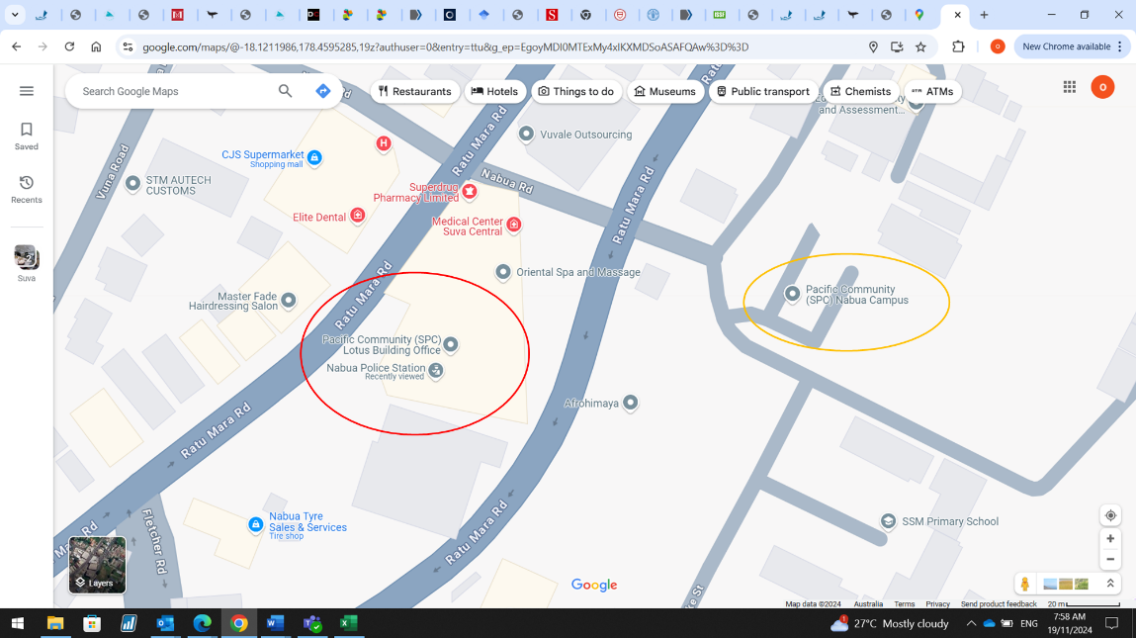

SPC has two campuses in Nabua. Our meeting is in the Lotus building (2nd Floor) (see red circle on screenshot). The Lotus building is above the Nabua police station. Entrance to the right of the police station entrance. If you get dropped off at the main campus (orange circle on screenshot) it’s a short 200m walk to the lotus building.

|  |
| --- |
| Agenda Item |
| 1. Introduction |
| 1. WCPFC Climate Indicators Overview    1. Indicator Framework    2. Candidate Regional Indicators |
| 1. Climate Indicators    1. Ocean State Reporting    2. National and Regional Ocean Indicators & Trends |
| 1. Fisheries Tuned Indicators    1. SDM    2. SEAPODYM    3. Fisheries    4. Decision related |
| 1. Framework for testing    1. Breakpoints    2. Track CC impacts    3. Empirical vrs Modelled |
| 1. Reporting    1. Met Services    2. Portals |

Tuesday 23rd November 2024, Fei Finomo Meeting Room Room, SPC Nabua (2nd Floor Lotus), Suva, Fiji, 9:30am-12:00pm

WCPFC Climate Indicators

|  |  |
| --- | --- |
|  | 1. Co-design/Resourcing    1. Collaboration network    2. Data Access |
|  | 1. Work plan |

## Workshop participants

|  |  |
| --- | --- |
| **Participant** | **Organisation** |
| Bernadette Sloyan | CSIRO, Australia |
| Bipendra Prakash | SPC, Fiji |
| Jone Amoe | SPC, Fiji |
| Naiten Bradley Phillip Jr | SPC, Federated States of Micronesia |
| Francis Tofuakalo | SPC, Solomon Islands |
| Nick Hill | SPC, New Caledonia |
| Simon Nicol | SPC, New Caledonia |
| Tuikolongahau Halafihi | SPC, New Caledonia |
| Victoria Pilbeam | SPC, New Caledonia |
| Lui Bell | SPC, Tonga |
| Lilis Sadiyah | NRIA, Indonesia |
| Fayakun Satria | NRIA, Indonesia |
| Emily Crigler | NOAA, USA |
| Felipe Carvalho | NOAA, USA |
| Ryan Rykaczewski | NOAA, USA |
| Pheobe Woodworth-Jercoats | NOAA, USA |
| Nicholas Ducharme-Barth | NOAA, USA |
| Glen Holmes | PEW, Australia |
| Johann Bell | Conservation International, Australia |
| Kara Miller | Conservation International, USA |
| Andrew Bassford | Marine Change, Hong Kong |
| Elaine Garvilles | WCPFC, FSM |
| SungKwon Soh | WCPFC, Federated States of Micronesia |